“SMART IV DRIP MONITORING SYSTEM”

Minor Project

Submitted by:-

ANURAG SINGH
VISHAL NANDA
NISHANT SINGH
VISHAL YADAV

0206EC201009
0206EC201060
0206EC201027
0206EC201061

in partial fulfillment for the award of the degree

of

BACHELOR OF ENGINEERING

in

ELECTRONICS & COMMUNICATION ENGINEERING



GYAN GANGA INSTITUTE OF TECHNOLOGY & SCIENCES
JABALPUR (M.P.)
RAJIV GANDHI PRODYOGIKI VISHWAVIDYALAYA,
BHOPAL (M.P.)
April- 2022

DECLARATION

We hereby declare that the project “Smart IV Drip Monitoring System” which is being submitted in partial fulfillment of the requirement for award of the Degree of Bachelor of Engineering in Electronics and Communication Engineering to “RAJIV GANDHI PROUDYOGIKI VISHWAVIDYALAYA, BHOPAL (M.P.)” is an authentic record of our own work done under the guidance of Mr. Sunil Kumar Shah, Associate Professor, Department of Electronics & Communication Engineering, GYAN GANGA INSTITUTE OF TECHNOLOGY & SCIENCES, JABALPUR.

The matter reported in this Project has not been submitted earlier for the award of any other degree.

Date:
Place: JABALPUR

CERTIFICATE

This is to certify that the Minor Project report entitled “Smart IV Drip Monitoring System” submitted by Anurag Singh, Vishal Yadav, Vishal Nanda, Nishant Singh has been carried out under my guidance & supervision. The project report is approved for submission towards partial fulfillment of the requirement for the award of degree of BACHELOR OF ENGINEERING in ELECTRONICS & COMMUNICATION ENGINEERING from RAJIV GANDHI PROUDYOGIKI VISHWA-VIDYALAYA, BHOPAL (M.P).

Mr. Sunil Kumar Shah  Guide  Dept. of Electronics and Communication Engineering | Dr. Neeta Nathani  HoD  Dept. of Electronics and Communication Engineering Engineering

ACKNOWLEDGEMENT

We sincerely express indebtedness to esteemed and revered guide Prof. Sunil Kumar Shah, Assistant Professor, Department of Electronics and Communication Engineering for his invaluable guidance, supervision and encouragement throughout the work. Without his kind patronage and guidance the synopsis would not have taken shape.
We take this opportunity to express deep sense of gratitude to Dr. Neeta Nathani, Head of Department of Electronics and Communication Engineering for her encouragement and kind approval. Also we thank her in providing the lab facility. We would like to express our sincere regards to her for advice and counseling from time to time.
We owe sincere thanks to all the faculty members of Department of Computer Science and Engineering for their advice and counselling time to time.

Date :
Place : JABALPUR

TABLE OF CONTENT

Serial No. | Title | Page No.
1 | INTRODUCTION
2 | LITERATURE REVIEW
3 | REQUIRED MATERIAL
4 | WORKFLOW
5 | PROJECT CODE
6 | FUTURE SCOPE
7 | CONCLUSION
8 | REFERENCES

1.INTRODUCTION

Drip Monitoring Therapy is the process of passing nutrients, food and necessary medicines directly in your bloodstream, with the help of a small tube called a catheter, bypassing your digestive tract. These fluids help maintain a patient's hydration, electrolyte and blood sugar levels while undergoing surgical procedures. A bottle filled with the necessary fluid medication is hung at a level higher than the patient's body to provide the fluid with a pressure created by gravitational potential energy, which overcomes the circulatory pressure. The existing Drip Monitoring system is manual and requires a nurse or a doctor to keep a check on the patient’s infusion setup. Traditionally, they need to approximate the time a bottle will take to empty and regular rounds are required to regulate the flow rate, and avoid any bubble formation which makes the manual Drip Monitoring system prone to human error. In most cases, the bottle is replaced when it is fully empty. The time it takes a nurse to replace an empty bag varies depending on factors such as the amount of medicine administered, variations in back pressure owing to systolic-diastolic and non-quantifiable dilation or contraction of veins. Since, this procedure is dynamic in terms of measurement, comprehensive monitoring that can warn nurses at precise percentages depending on the type of the electrolyte in the drip and the time required to replace the IV(Intravenous) infusion bag is required. If nurses do not stop or replace the infusion at the appropriate moment when the bottle is empty and the infusion procedure is complete, it might result in an air embolism in the IV tube, which can be fatal or harm the patients' health.

This project proposes a method for hospitals to efficiently monitor drip infusion levels. Our proposed system consists of a load cell which helps to detect the level of fluid . A control mechanism can alert the nurses or doctors if the fluid levels in the IV infusion bag drops down a certain level to prevent air embolism and avoid reverse flow of blood. After that it's up to the nurse if he/she wants to continue or change the IV bag. This project significantly improves the overall efficiency of the hospital personnel. Our main aim of this project is to provide a reliable, cost effective and automatic drip monitoring system which anyone can implement or operate easily without any problem. Since necessary presence or regular monitoring of patients is not required, the proposed method will greatly benefit hospital staff. It also prevents any chance of human error caused due to overflow in the hospital.

2. LITERATURE REVIEW

Intravenous drip meter & controller by Raghavendra B. In this system, IV drip usage and a solution is proposed to enable monitoring and control of IV drip based on sensing of drops falling through the drip chamber. Such a device will potentially reduce complication and provide peace of mind to users of IV drip system. Here embedded system technology was used and system was run without a regulator to save battery power. The device displays the flow rate and also has alarms which operate when the rate deviates from pre-set value. A power management circuit along with a battery will be used to provide power to various components and circuits.

Intravenous Drip Monitoring System by M. Anand . In this system, the IV fluid monitoring system automatically sends a message to the nurse through GSM technology. This technology reduces the work of the nurse instead of keep on watching of an IV fluid system. The automation circuit is built around the Arduino Uno R3; Solenoid valve is used to cut off the fluid drip system. The control system can be better in time consumption; the system can easily control the hardware by use the arduino controller. This project provides the advantages for nurse/assists in healthcare system and control of notice board generally.

Design and Development of IOT enabled IV infusion rate monitoring and control device for precision care and portability by Mohammed Arfan. This paper proposes a drip monitoring and control device that fits on the existing Intravenous setup. Normally, doctors and nurses use their experience to estimate the time required for a drip bottle to be empty and for setting drip rate. This makes the IV infusion method to be vulnerable to human error and there are also other risks like back flow of blood and many others if not attended when empty. This paper proposes an IoT monitoring and control platform for IV infusion setup which enables doctors and nurses to monitor as well as control the IV infusion setup wirelessly while keeping the cost low and making the device highly reliable.

3. REQUIRED MATERIAL

The proposed system makes use of Arduino Uno, 5 kg Load Cell, HC-05 Bluetooth Module, Buzzer.

a) Arduino Uno:
In this project we use an Arduino Uno board which is equipped with ATmega328P, an 8-bit AVR microcontroller chip, which is the main heart of Arduino Uno board. The Arduino Uno board is used to regulate the operation of the suggested system since it controls the sensors, processes the data and then display it to the LCD screen and arduino_poids app with the help of bluetooth module.

b) Load Cell:
We use a 5kg load cell, load cell helps to calculate weight , it is based on the principle of piezo resistivity . This principle states that the electric charge obtained is proportional to the applied mechanical stress

c) HC-05:
Bluetooth Module HC-05 generally used to connect small devices like mobile phones using a short-range wireless connection to exchange files. It uses the 2.45GHz frequency band. The transfer rate of the data can vary up to 1Mbps and is in range of 10 meters.

d) Lcd-Display:
The term LCD stands for liquid crystal display. It is one kind of electronic display module used in an extensive range of applications like various circuits & devices like mobile phones, calculators, computers, TV sets, etc. These displays are mainly preferred for multi-segment light-emitting diodes and seven segments. Here LCD display is used to display the drip level , 16x2 LCD display is used here.

e)Buzzer:
An audio signaling device like a beeper or buzzer may be electromechanical or piezoelectric or mechanical type. The main function of this is to convert the signal from audio to sound. Generally, it is powered through DC voltage and used in timers, alarm devices, printers, alarms, computers, etc. Based on the various designs, it can generate different sounds like alarm, music, bell & siren. For better understanding of project we added buzzer, which will work as a alert signal when the drip is going to be ended.

4. WORKFLOW
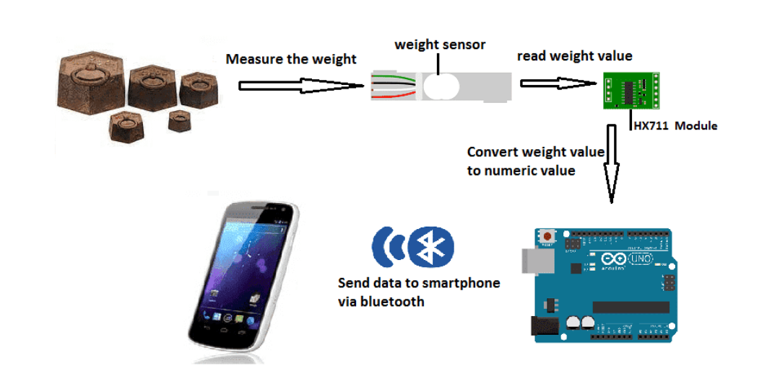

Figure representing Workflow of the project

4.1 Working
In above figure weight represents the weight of glucose bottle, the weight is hanged, and mechanical stress is applied to load cell, load cell convert it into electrical pule and with the help of HX711 it is amplified and signal is send to arduino. Arduino process the signal and with the help of the Bluetooth Module (HC-05), it display the reading in Smartphone.

4.2 Project Screenshots

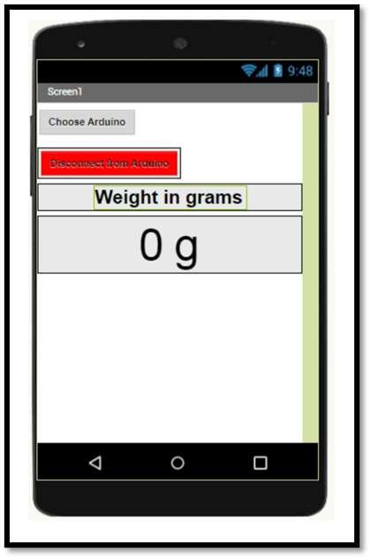
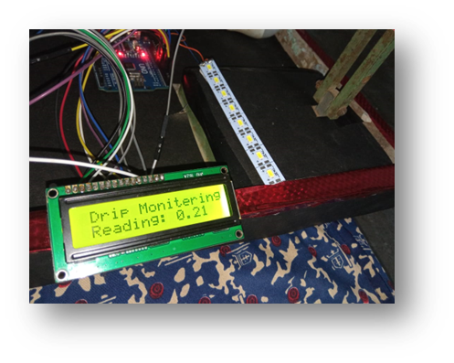

a) Representing regarding in LCD
screen

b) Arduino_poids app view

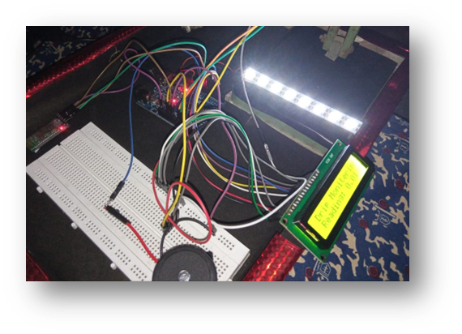
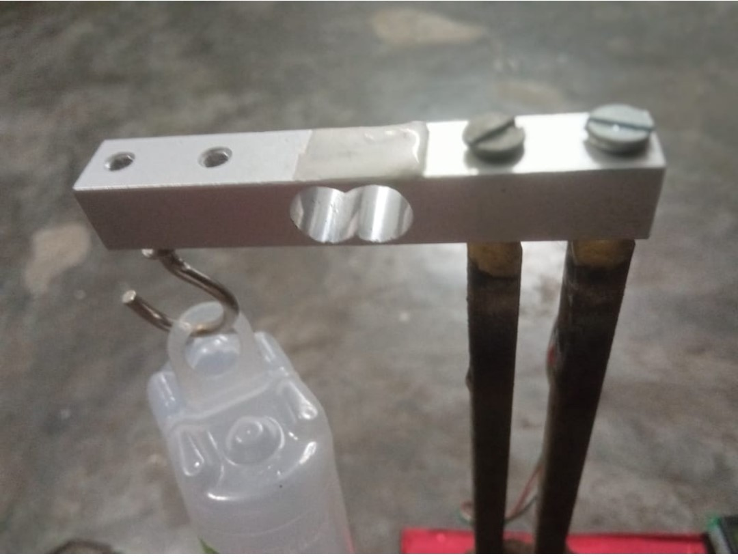

d) Load Cell (5 KG)

c) Overview of project

5. CODING

5.1 Arduino Code:
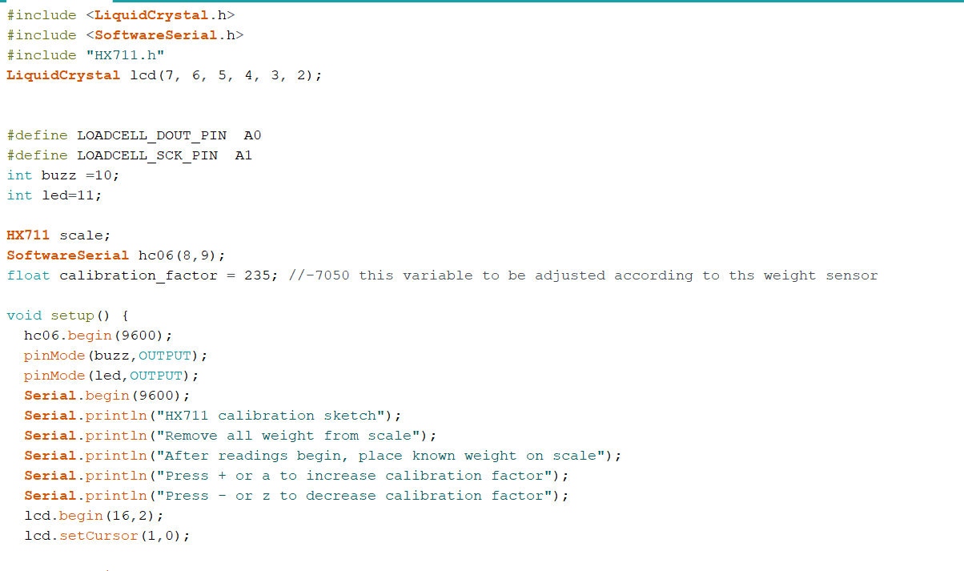
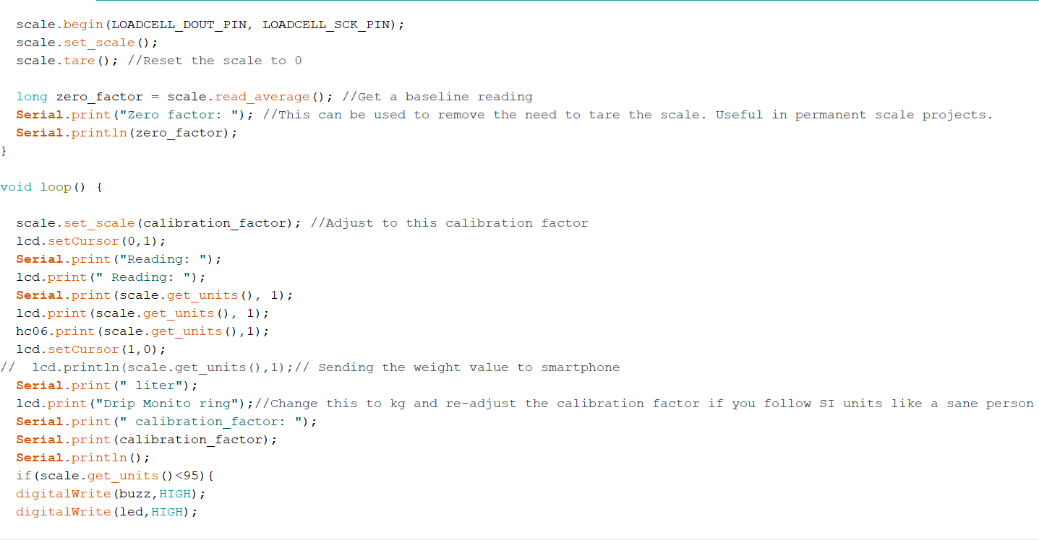
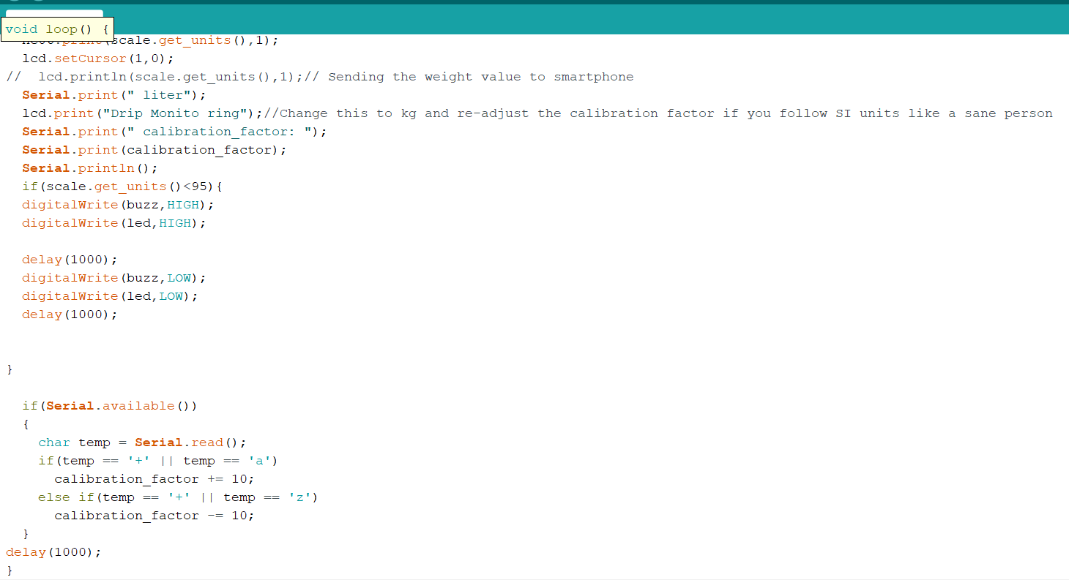

5.2 MIT App Builder Code:
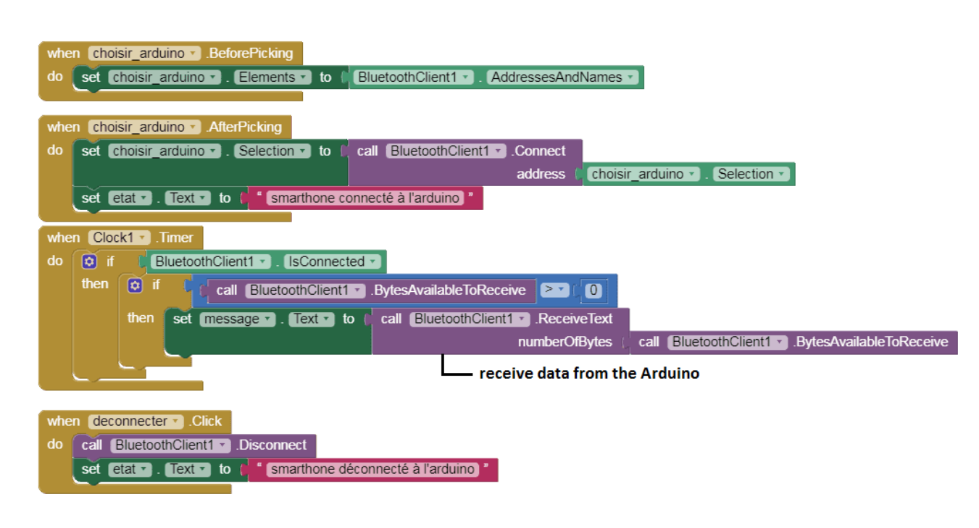
6. FUTURE SCOPE

- Development of a fully functional app that can manage multiple patients data, along with detection of heart beat, pulse,sugar level

- Developing a technique through which flow control of glucose drip can be done wirelessly

- Development of such technique through which multiple glucose drip can be operated by single microcontroller

- Making a complete product which has a good accuracy and cost efficient also

7. CONCLUSION

This study proposes an IoT-based monitoring and control platform for IV infusion setup. The suggested work decreases the amount of time and effort required to monitor the infusion setup and allows for wireless monitoring. It helps in ensuring there is zero margin of error as improper administration of drip can lead to many problems. It also improves clinical efficiency, safety and patient experience in hospitals and makes home care possible for many patients. This system may be quickly installed on the stand where the drip bottle is hung, in order to reduce the workload of nursing staff we proposed this project which can overcome number of problems during IV therapy

8. REFERENCES

[1] H. Amano, Hidekuni Ogawa, W. Caldwell, “A remote drip infusion monitoring system employing Bluetooth,” 2012 Annual International Conference of the IEEE Engineering in Medicine and Biology Society, 2012. DOI:10.1109/EMBC.2012.6346356 [2] Raghavendra B, Vijayalakshmi K, Manish Arora, “Intravenous drip meter & controller,” 2016 8th International Conference on Communication Systems and Networks (COMSNETS), 2016. DOI:10.1109/COMSNETS.2016.7440024 [3] M, Anand and MM, Pradeep and Manoj, S and Raj, Marcel Arockia and Thamaraikani, P., “Intravenous Drip Monitoring System,” 2018 Indo-Iranian Jour-nal of Scientific Research (IIJSR), 2018. DOI:10.2139/ssrn.3536333 .
[4] https://www.robotique.tech/robotics/weighing-scale-using-hx711-and-arduino-for-remote-weight-monitoring-by-bluetooth.

